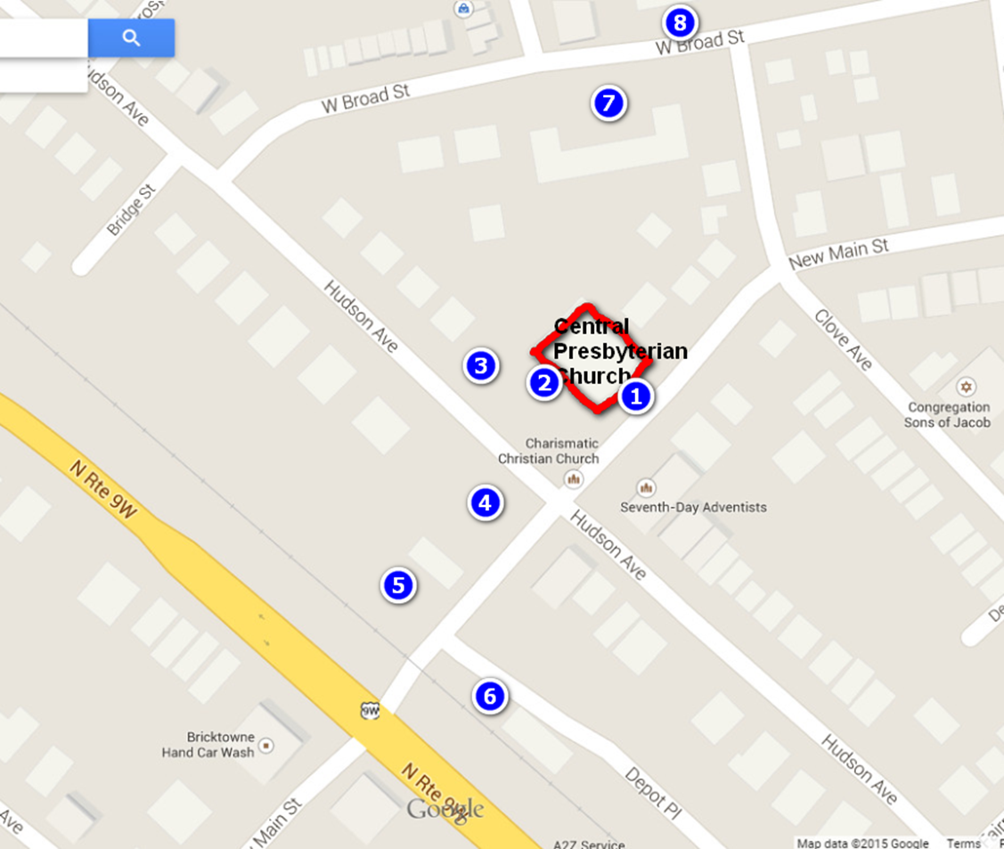

- Food drop-off (drive through)
- Worship entrance
- Parking for handicapped worshippers
- Parking (Catholic Charities)
- Parking (city property)
- Parking (Stein & Stein)
- Parking (municipal lot)
- Parking (municipal lot)

PARKING IS ALSO AVAILABLE ON HUDSON AND NEW MAIN STREETS

Join 9 Rockland PC(USA) Congregations
for part or all of the following:

9:30am Gathering Drop off food & enjoy a cup of coffee

10:30am Worship Holy Communion, Combined choir,
Rev. Dr. Susan Andrews preaching
12:00pm Lunch & Fellowship Bring a dish to share and get to know your neighbors
12:45pm Ministry Fair Learn about opportunities for county-wide ministry collaboration

For more information contact Debbie Bradley at 845-429-5111
or Rhonda Kruse at rhonda@hudrivpres.org.

(Over for food drop-off and parking locations.)
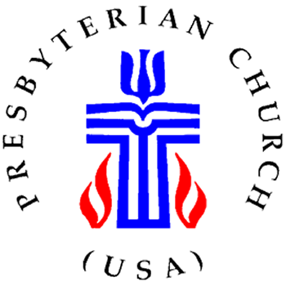
Rockland Presbyterians
in Community
Gathering in worship together
to celebrate Christ among us
April 19, 2015
Central Presbyterian Church
89 Hudson Avenue
Haverstraw, NY

